**Project Design Phase-II**

**Technology Stack (Architecture & Stack)**

|  |  |
| --- | --- |
| Date | 3 October 2022 |
| Team ID | PNT2022TMID53278 |
| Project Name | Corporate employee attrition analytics |
| Maximum Marks | 4 Marks |

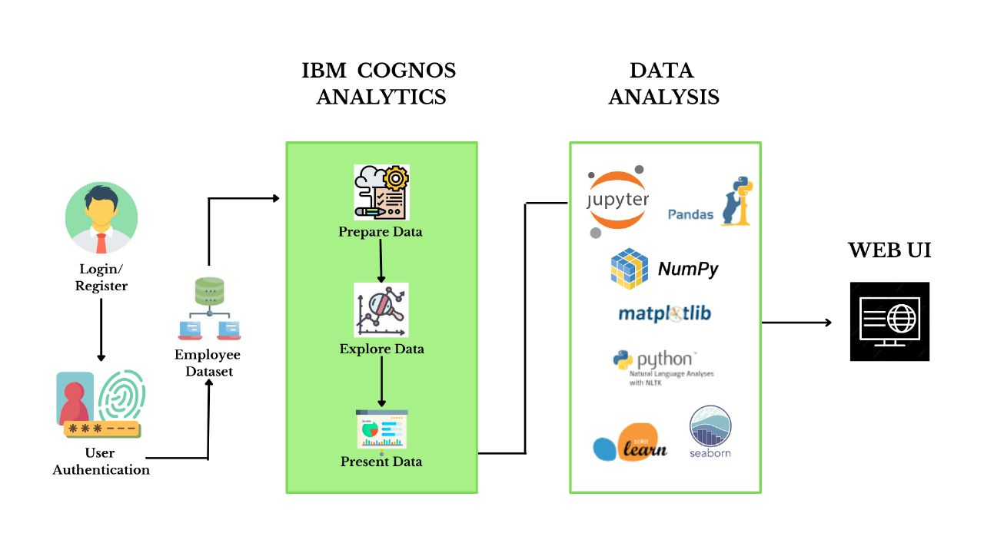

**Table-1 : Components & Technologies:**

|  |  |  |  |
| --- | --- | --- | --- |
| **S. No** | **Component** | **Description** | **Technology** |
|  | User Interface | The user must interact with IBM Cognos technology and upload the dataset for analysis. | IBM Cognos |
|  | Data cleaning | Only the required data fields are selected and unwanted data is discarded | IBM Cognos |
|  | Relationship Establishment | Relationships across data fields is established | IBM Cognos |
|  | Application Logic 1 | The dataset is read and the results are visualized in the form of pie charts and bar graphs | IBM Cognos |
|  | Machine Learning Model | To predict the accurate reason for which employees leave a company. | Google collab and deep learning models |
|  | Dataset | Contains all the data of various factors faced by an employee | Kaggle |
|  | Application Logic 2 | Used for analysing the dataset and displaying the necessary results | Python |

**Table-2: Application Characteristics:**

| **S. No** | **Characteristics** | **Description** | **Technology** |
| --- | --- | --- | --- |
|  | Open-Source Frameworks | Open source software is **code that is designed to be publicly accessible**—anyone can see, modify, and distribute the code as they see fit. | Google collab, Jupyter notebook |
|  | Security Implementations | IBM cloud application provides security features that are in addition to many of the components identified in the security framework. | IBM Cloud Pak for security |
| 3. | Scalable Architecture | Python's flexibility also allows Ray to instrument Python code to make ML/AI scalability possible without requiring distributed systems expertise and lots of invasive code changes. Hence, ML/AI users get the benefits of cluster-wide scalability with minimal effort. | Python |
|  | Availability | Availability is the ability of the system to withstand or recover from exceptional situation. | Google collab |
|  | Performance | Application performance indicates how the app is functioning and how responsive the app is to the end-user. There are tools available to measure Application Performance and enable app developers to detect and diagnose complex application performance problems to maintain the expected level of service to end-users. | Google collab/ Python |